**Default Termination Policy in ELB:**

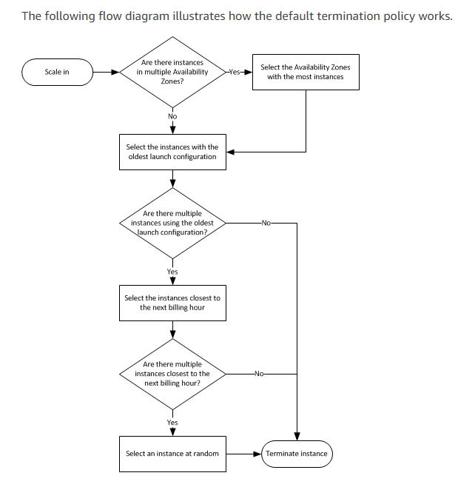

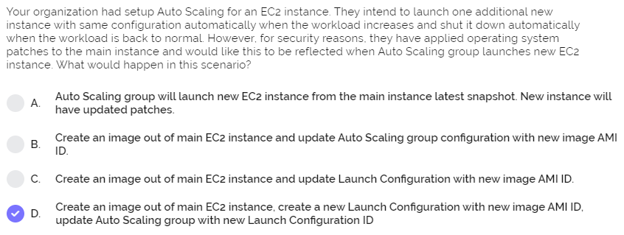

By default, Auto Scaling **does** not facilitate the option of **update launch configuration**. But if **you** want to **update** the AMI, User data or Instance type, **you** need to create a new **launch configuration** and then **update** the same into the Auto Scaling group.

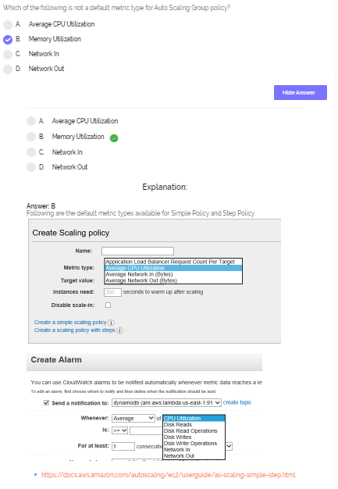

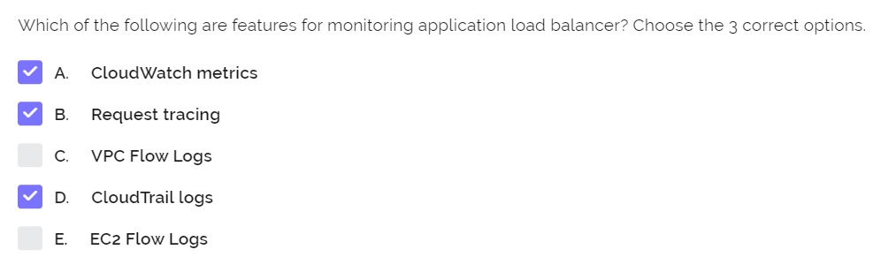

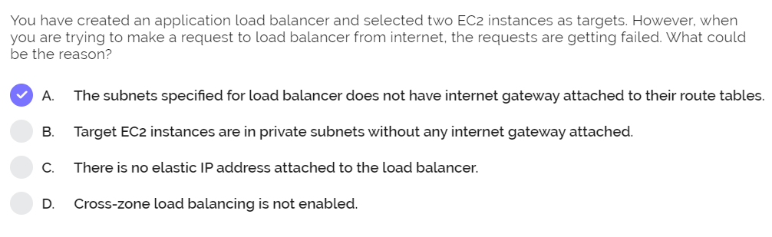

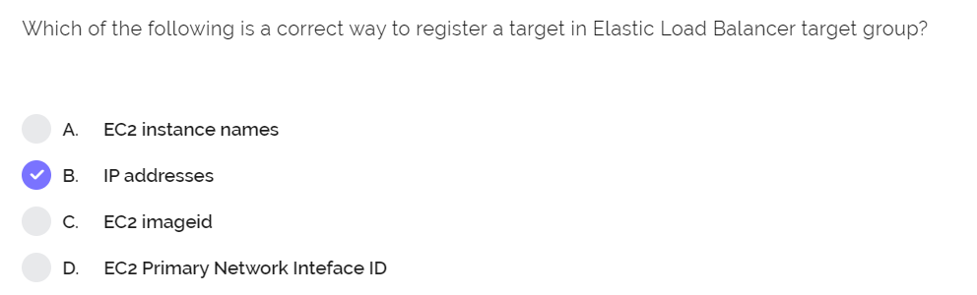

Can be done by IP addresses and also instance IDs

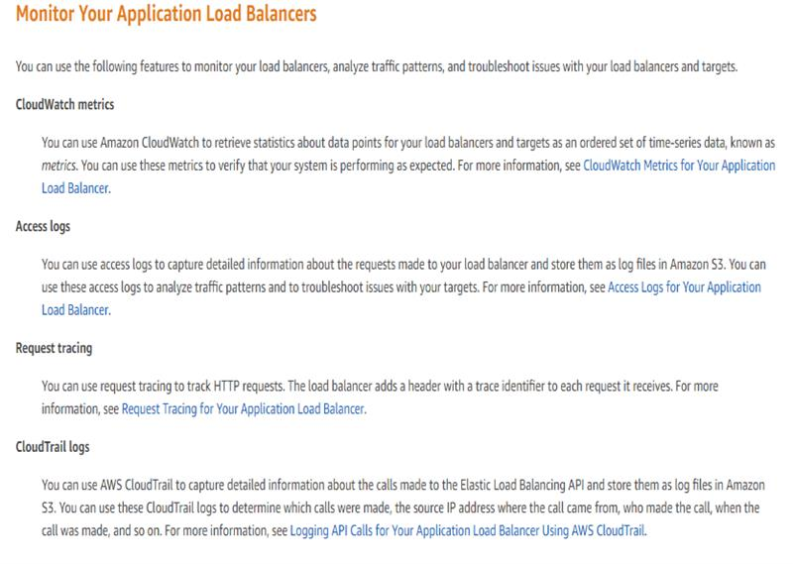

**Very important NLB question:**

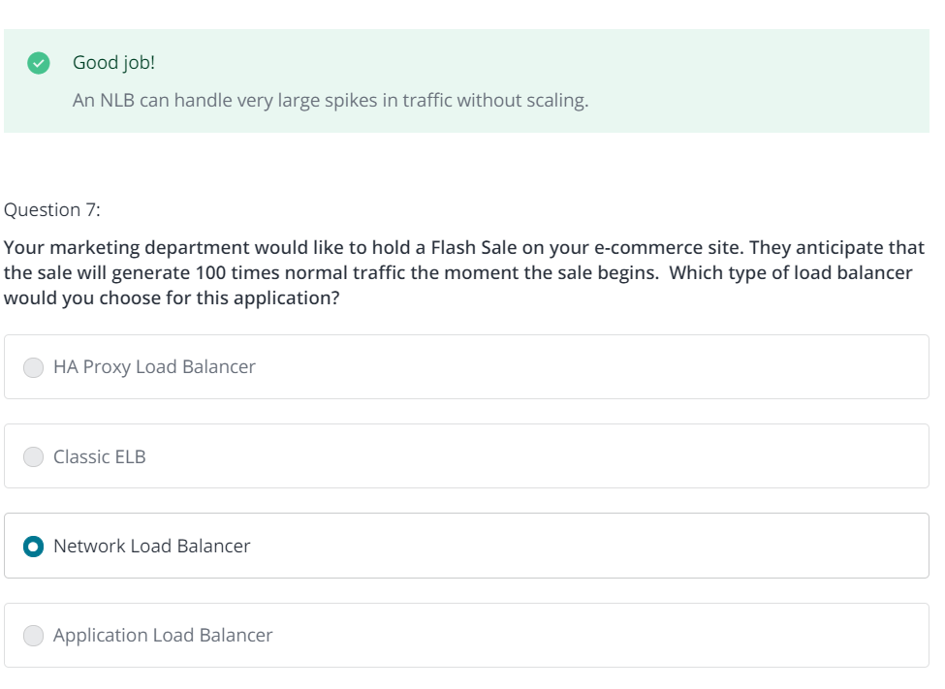

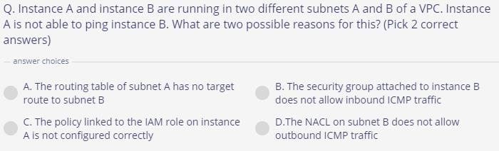

Ans: **B and D**

To be able to ping, always allow ICMP traffic for NACL and Security Group.

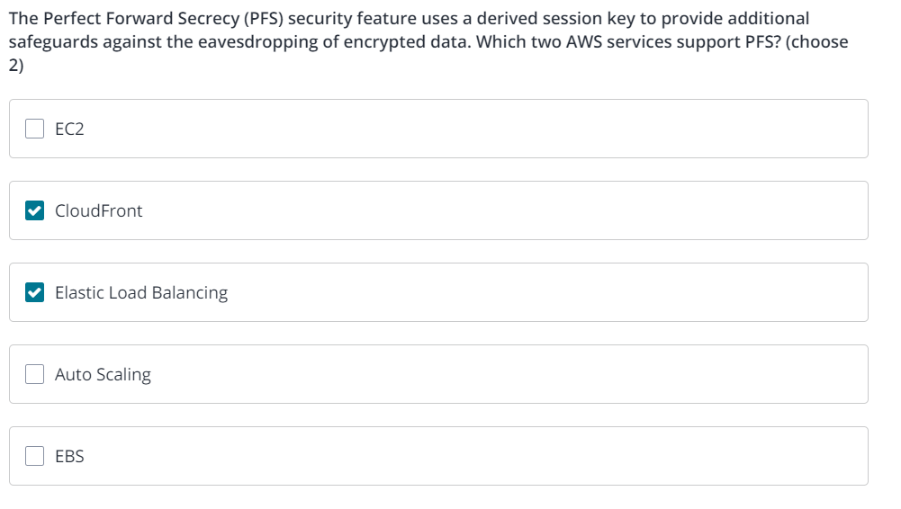

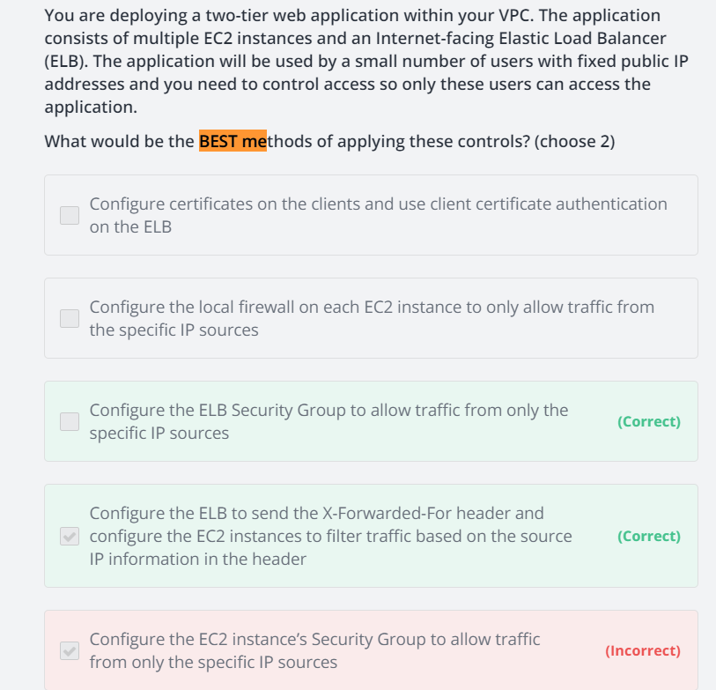

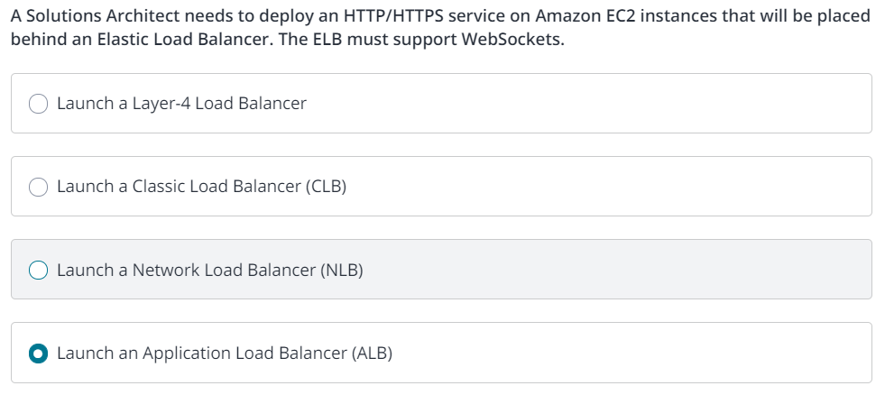

**Important:**

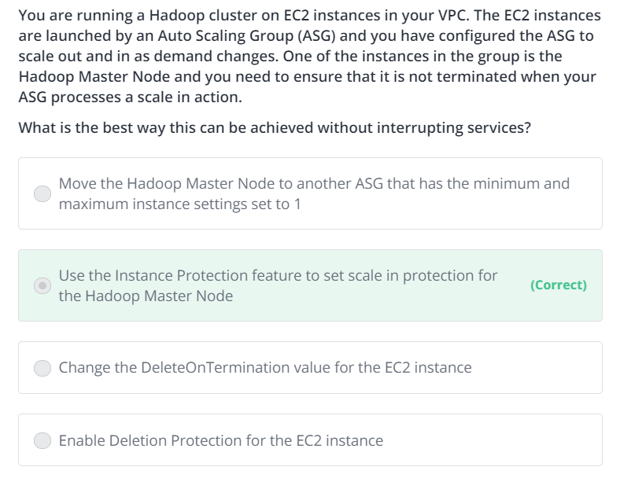

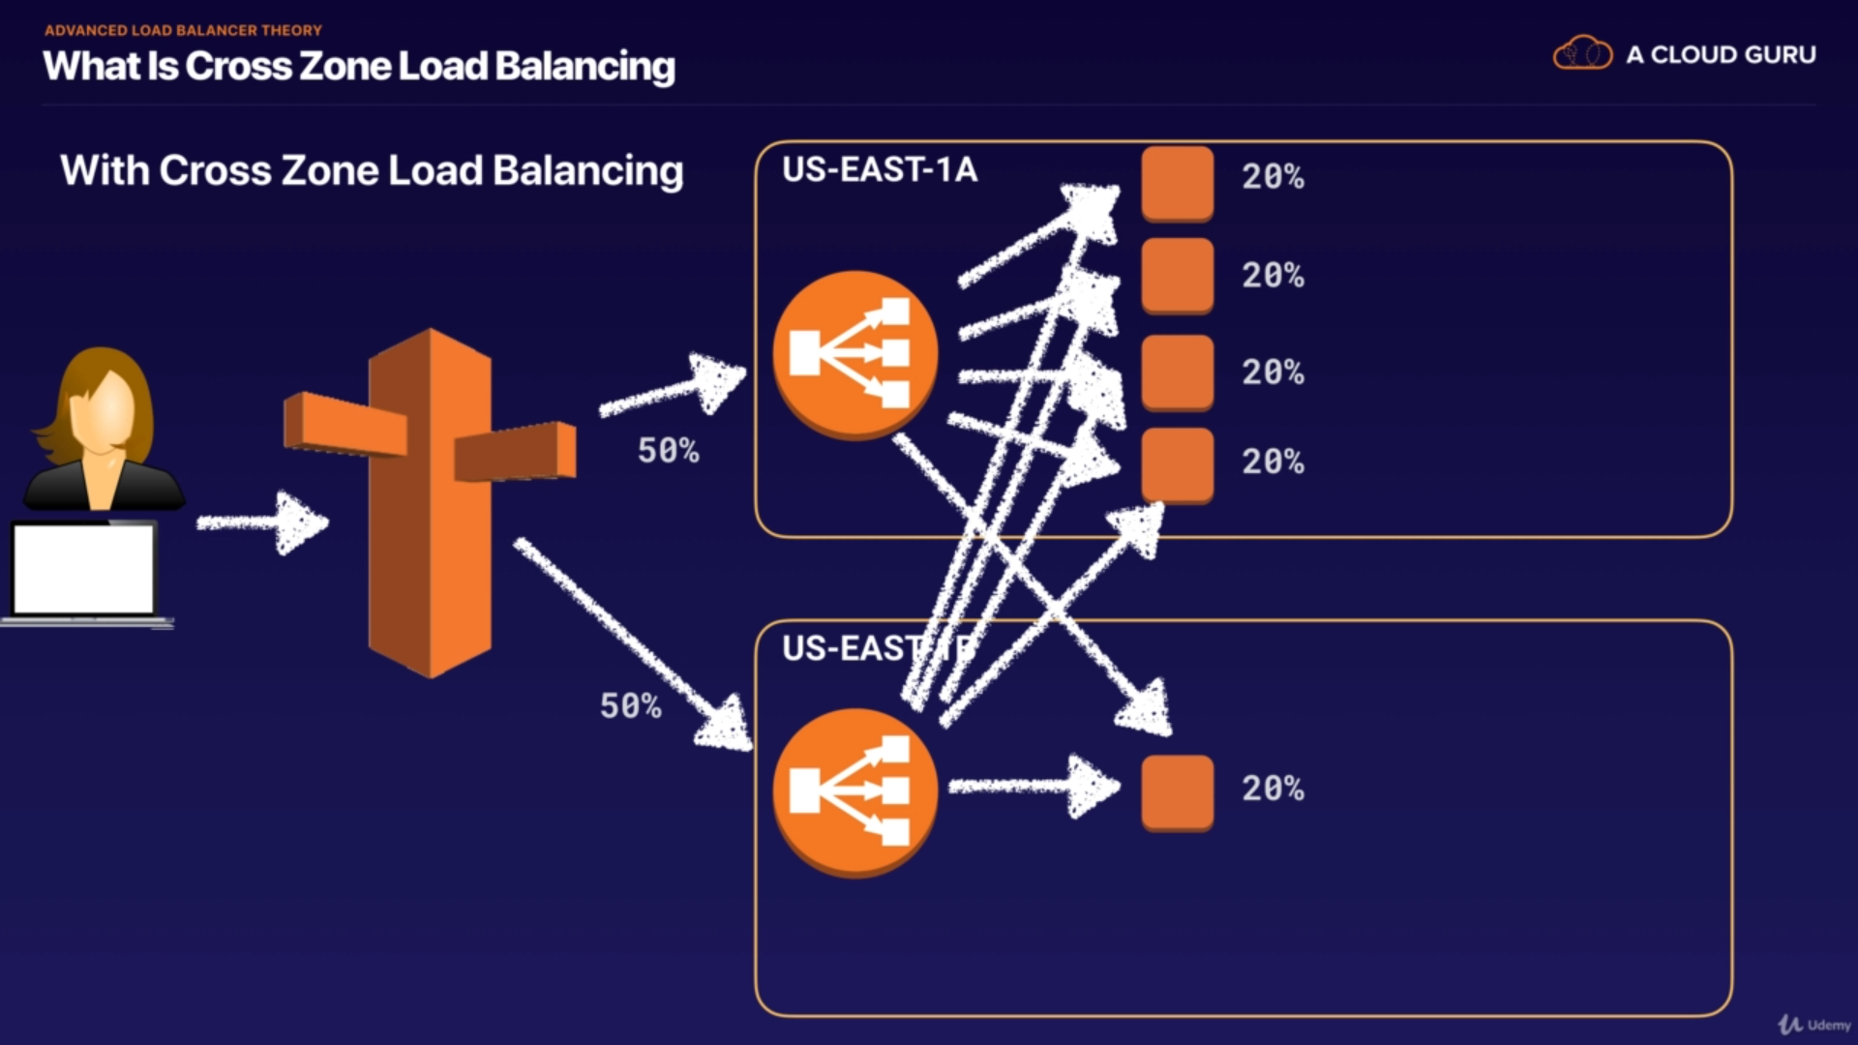

Cross-zone load balancing to equally split the traffic across the AZs.

Exam Scenario for the below question:

100% of traffic is being sent only to one AZ, then enabling Cross-zone Load Balancing enables traffic to be sent to Instance in another AZ

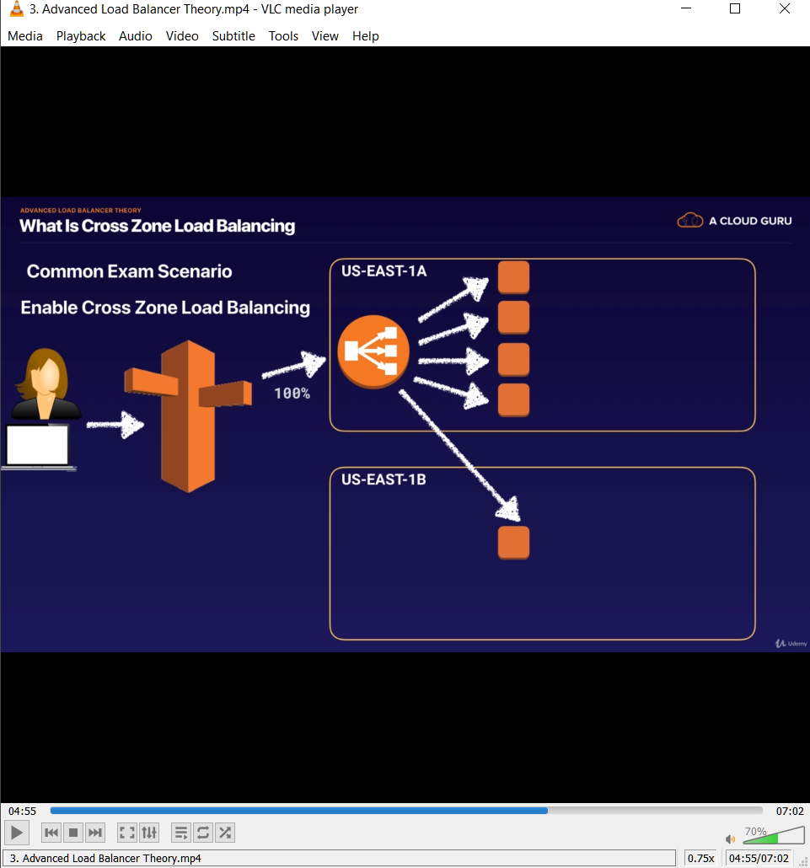

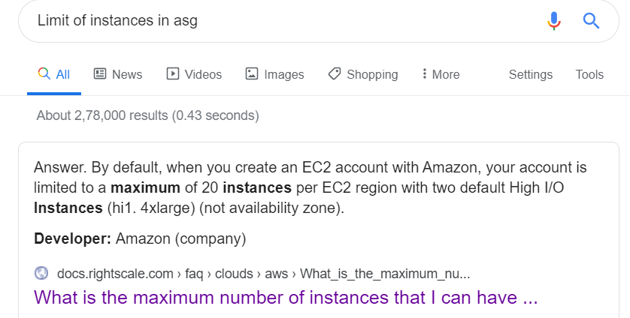

**NOTE:**

In ALB, enabling **Path pattern**, can help send traffic to instances in separate AZs having instances set for specific task according to URLs.

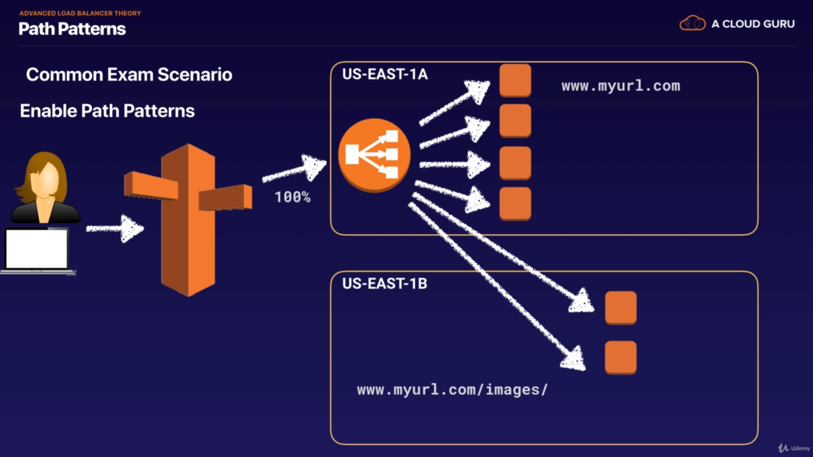

**Sticky Sessions**:

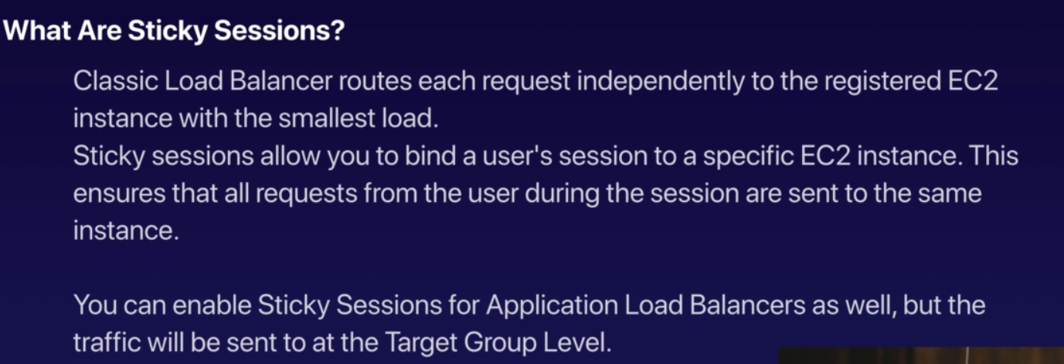

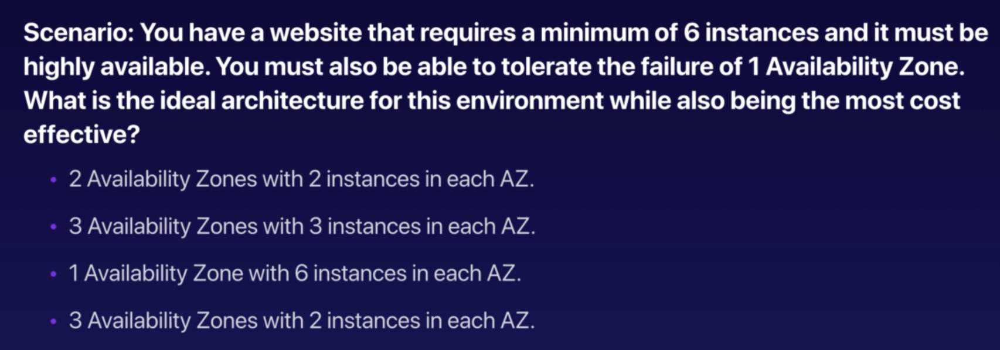

ANS: 2nd option

